History :

|  |  |
| --- | --- |
| Objective | Data |
| Personal Data | * Name * Age * Menstural Cycle * Marital status * Number of children * Residency (areas with iodine deficiency). * Occupation * Special habits * Chronic diseases. |
| Chief complaint | * Neck Swelling * Neck Pain |
| Present History | * Analysis of complaint * Associated symptoms * History suggesting **hypothyroidism.** * History suggesting **hyperthyroidism**. |
| Past History | * Neck radiation exposure. * Recent pregnancy (postpartum thyroiditis). * History of hyperprolacinemia or breast feeding (feedback inhibition on TSH). * Previous investigations. * Previous Clinic visits * Chronic diseases * Hospital admissions * Previous Surgeries and complications. |
| Familial History | * Autoimmune diseases.   And the age of those affected. |
| Drug History | * Prescribed drugs * OTC * Topical drugs * Amiodarone (antiarrhythmic). * lithium * Radioactive iodine therapy. * Thionamides (PTU/methimazole/carbimazole --> - TPO and deiodonation of T4 in peripheral tissues) |
| Other Systems Complaints | * Systems review |

Common presenting complaints :   
1) Neck Swelling :

|  |  |  |  |
| --- | --- | --- | --- |
| Swelling | Description | Etiology | Treatment |
| Non-toxic Goiter (simple diffuse or multinodular) | - Euthyroid or Dysfunction  - Compression symptoms in huge diffuse goiters | * Iodine deficiency. * Physiological. (lactation/pregnancy/stress). * Colloid goiter. * Drug induced (thionamides/PTU/amiodarone -- a 3rd gen antiarrhythmic drug). | * Subtotal thyroidectomy. * Lobectomy. * Total thyroidectomy. * Radioiodine ablation. * Thionamides are contraindicated.   + Hormone replacement therapy |
| Toxic diffuse Goiter (grave’s disease) | Usually hyperfunction but may express hypofunction features concurrently in 80% of cases due to TPO+AB. | * TSI antibodies creates an autonomous gland by increasing the sensitivity of TSH-R. * Sudden increase in iodine intake. | * Thionamides (PTU/carbimazole) -> -- TPO. * Radioiodine ablation. |
| Autoimmune thyroiditis | Hypofunction | * TPOAb+ -> destruction of TPO enzyme -> failure of oxidation/organification and iodoniation. | * Treat the hypothyroidism with HRT. |
| Subacute thyroiditis (de Quervain’s) | Express a sort of tenderness & hotness | * Inflammatory infilterates due to viral infection. | * NSAIDs * Corticosteriods * HRT wit low doses during the hypofunction phase (after the follicular destructive phase). |
| Retrosternal goitre | Compressive symptoms : **Dysphagia**, **breathlessness**, **stridor**. | * Large thyroid goitre or tumors. | * Urgent surgery may be needed if there were compressive symptoms. |

2) Neck Pain :

|  |  |
| --- | --- |
| Disorder | Associated symptoms |
| Subacute/acute /inflammatory thyroiditis | Redness and hotness |
| Bleeding into thyroid nodule | Redness and hotness |

3) History suggesting hypothyroidism.  
4) History suggesting hyperthyroidism.

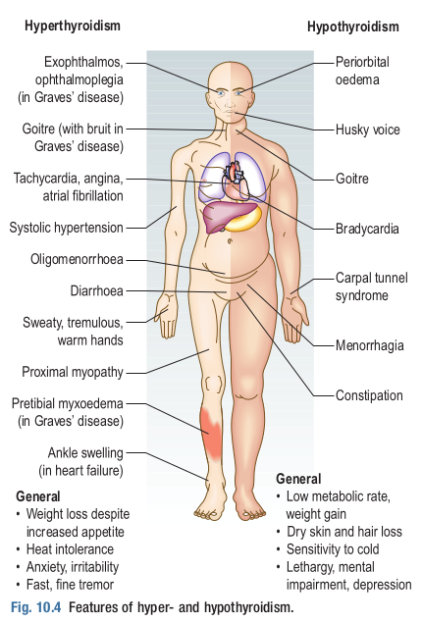

Investigations Schemes :

|  |
| --- |
| Hypothyroidism workout |
|  |
| Hyperthyroidism workout |
|  |

General Examination :

|  |
| --- |
| Observe |
| For signs of hyper or hypo thyroidism : |
| Inspect Hands for |
| * Vitiligo. * Thyroid acropachy. * Onycholysis. * Palmar erythema. |
| Assess |
| * Pulse. * Blood pressure. * Water hammer pulse. |
| Auscultate |
| The heart apex for mid-systolic flow murmurs in hyperthyroidism. |
| Asses proximal muscles power and deep tendon reflex |
|  |

Local Examination :

|  |
| --- |
| Inspection |
| * The Neck from the front, look for any asymmetry/scars/swellings. * The Neck from the sides, while **the neck is slightly extended.** * The Neck while **the patient takes a sip of water and swallow**. * Notice the thyroid is moving with the trachea up and down. * Inspect for any **mass** in the neck and **comment your findings**. |
| Palpation |
| * Thyroid lobes      * Lymph nodes  |  |  | | --- | --- | |  |  | |
| Percussion |
| Percussion over the sternum for retrosternal extension of the goiter (may express some compression symptoms) |
| Auscultation |
| If the thyroid gland is enlarged, over the thyroid lateral lobes to identify bruits, a sign of hyperthyroidism |

Comment on thyroid lump :

--> Onset (When it first appears ?).

--> Number (How many lumps out there ?).

--> Size (How big ?).

--> Location (Where ?).

--> Consistency (Soft, firm or hard).

--> Course (increasing in size ?).

--> Tenderness (is it sore to touch ?).

--> Relation to surroundings (mobile or fixed to the surroundings).

--> Associated Symptoms (pain/skin changes/hoarsness of voice/stridor/breathlessness episodes/hotness ?).

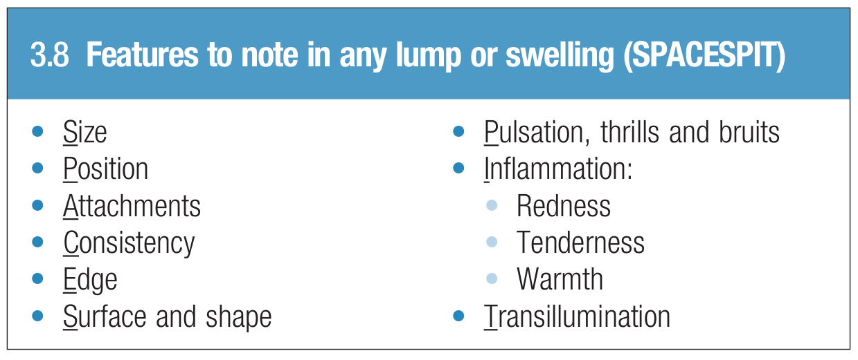

Thumbnails